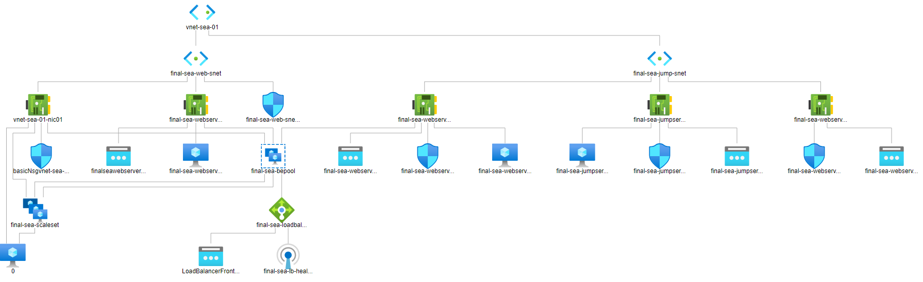

2 Resource groups created:

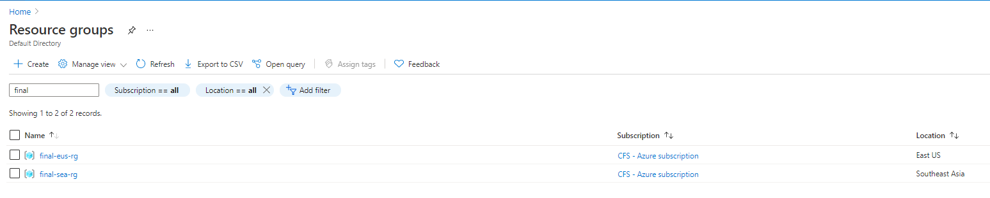

2 vnets created:

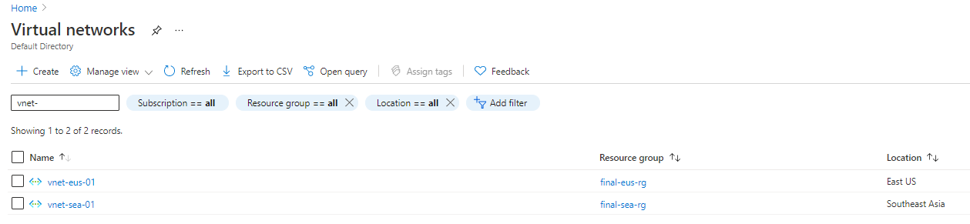

For vnet-eus-01 created 1 subnet:

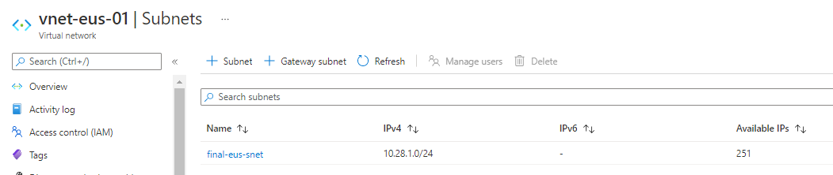

For vnet-sea-01 created 2 subnets:

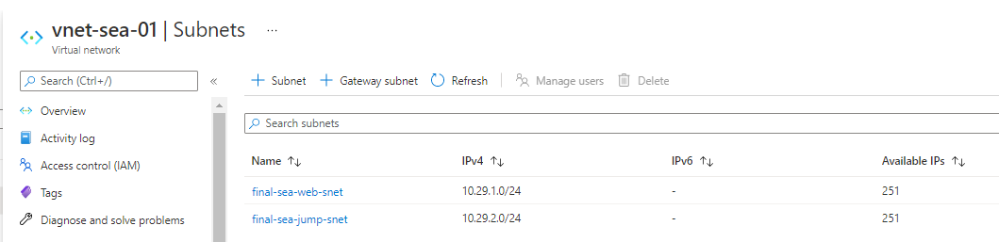

Vnet peering setup between vnet-eus-01 and vnet-sea-01:

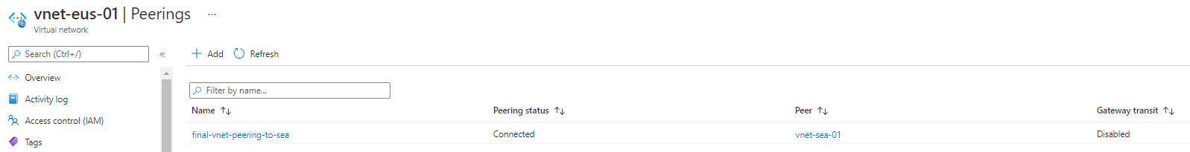

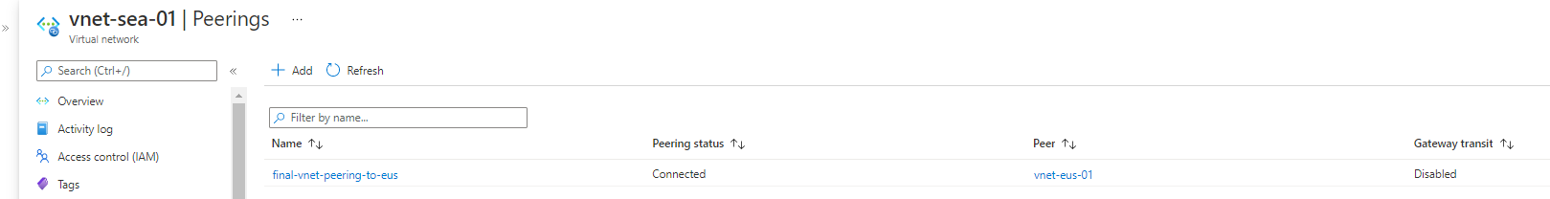

2 Webserver vms created on subnet final-sea-web-snet:

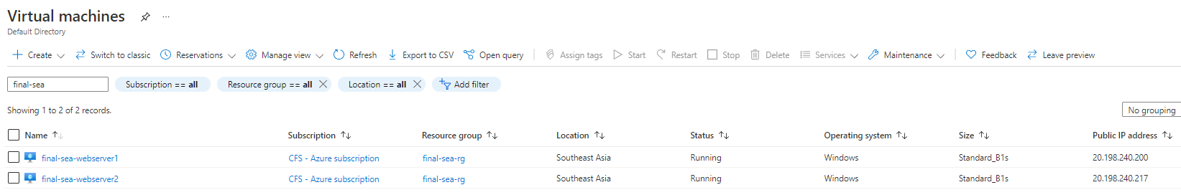

1 Jumpserver vm created on subnet final-sea-jump-snet:

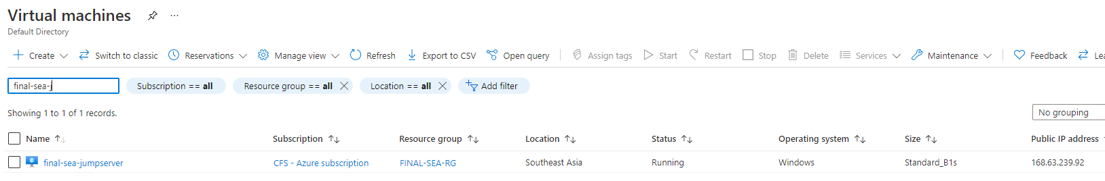

NSG for the final-sea-web-snet and final-sea-jump-snet:

